I B. Tech II Semester Supplementary Examinations – June, 2025

BASICS OF ELECTRICAL & ELECTRONICS ENGINEERING
(CSE/IT)
Time: 150 Min Max. Marks: 60M

SECTION – A
Answer all Four questions 4×8M=32M

  - Explain the limitations of Kirchhoff's laws.
  - Calculate the voltage V in the circuit shown in Fig. 1.

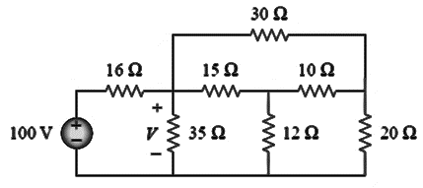
Fig. 1
  - Determine the value of R in the circuit shown in Fig. 2 that would cause the current source to deliver 800 mW to the resistors?
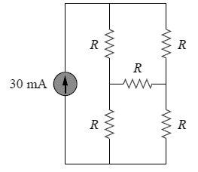
Fig. 2

  - Explain why AC voltage is typically measured in terms of its root mean square (RMS) value.
  - Determine the RMS value of the voltage waveform shown in Fig. 3, as well as the average power absorbed by a 2 Ω resistor when the voltage is applied across the resistor.
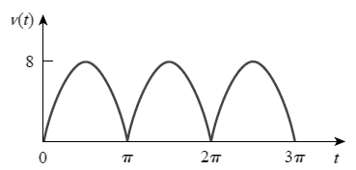
Fig. 3
  - For each of the following cases, calculate the apparent power, active power, and reactive power:
    - v(t) = 112 cos(ωt + 10°) V, i(t) = 4 cos(ωt − 50°) A
    - v(t) = 160 cos(377t) V, i(t) = 4 cos(377t + 45°) A

  - Explain the phenomenon of mutual inductance among three inductors (coils)?
  - Describe the phenomena that oppose the magnetic flux in a magnetic circuit, and explain how this opposition is influenced by the physical parameters involved, using relevant equations.
  - In the phasor-domain circuit represented by Fig. 4, let V₁ = 10∟−80° V, V₂ = 4∟−0° V, and V₃ = 2∟−23° V. Calculate I₁ and I₂.
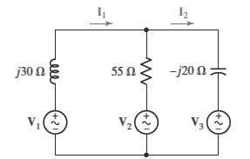
Fig. 4
- a. Explain whether the Voltage is proportional to Current (V α I) or Current is proportional to Voltage (I α V) according to Ohm’s Law.
b. Given three lightbulbs connected to a 9-V battery as shown in Fig. 5. Calculate:
    - the total current supplied by the battery
    - the current through each bulb
    - the resistance of each bulb.
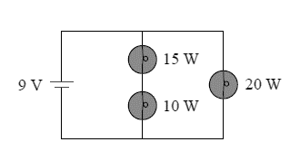
Fig. 5
- Refer to Fig. 6 and consider N = 10, each with a power rating of 40 W. If the voltage at the plug is 110 V, calculate the current through each bulb for both parallel and series connections.
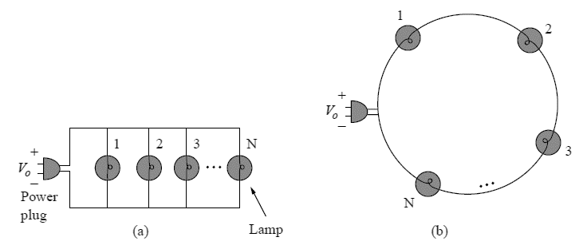
Fig. 6

SECTION - B
Answer all Two questions 2×14M=28M

  - Explain the significant use of the neutral point in a 3-phase star connected system.
  - Define a balanced three-phase system precisely and discuss some applications in which it can be utilized.
  - A balanced Y-connected load with a phase impedance of 16 + j9 Ω is connected to a balanced three-phase source with a line voltage of 220 V. Calculate the line current I_{L}.
  - Solve for the line currents in the Y-Δ circuit of Fig. 7. Take Z = 60 ∟45° Ω.

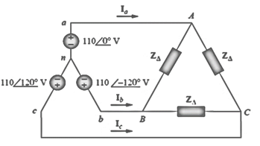
Fig. 7

  - Differentiate between the most widely used semiconducting materials – silicon and Germanium in application point of view.
  - Explain the function of each component in a phone charger circuit.
  - Describe the operation of an efficient rectifier circuit within a phone charger.
  - Select a specific electronic switch and explain how its voltage-current (V-I) characteristics make it suitable for use as an electronic switch.

